The Future of Ham Radio

Stiv Ostenberg, K9STV

It’s no secret that the demographics of Ham Radio show us heading towards a generational cliff. Ham Radio enthusiasts average age is climbing up, and new people are not coming on board faster than we are going silent key. As the Community Outreach Officer, I am trying to tackle this problem in the South Bay and beyond.

The fact that you are reading this column tells me that you are likely a Radio Operator. I don’t know what inspired you to get your license, and to continue to participate. Do you remember? As a newish operator myself, I am overwhelmed by all the different aspects there are to the hobby. So much to explore! So much to learn and do! Why aren’t people joining in droves? Why are people getting their license and then vanishing?

These are the questions I had to answer before I could start trying to address the problem. As in my professional career, I used my own experience as a metric. Why did it take me so long to get my General License? Why don’t I have any of my county credentials? Why did I not get my license earlier? It is my belief that answering those questions will help solve the problem.

# Why aren’t people getting their licenses?

In today’s world, we all carry a radio on our pocket. We can use it to call people anywhere in the world. Ham Radio is archaic and obsolete. Getting a license is difficult and requires you learn Morse Code. Ham Radio is just for old geezers who live in a shack…. Or so people believe.

If we want to save Ham Radio, we need to set the record straight. Ham Radio is relevant, getting a license is not a huge barrier, and there are lots of activities, both fun and related to disaster preparedness that simply are not possible with a cell phone.

This has been our failure. We have failed to reach the next generation and educate them about Ham Radio. The Internet is so bright and shiny that people get distracted and forget how fragile it actually is.

As Community Outreach Officer I have been attending the Electronics Flea Market every month with a booth to let people know about the world that opens before them with an Amateur License. I try to set up a demo station, and encourage others to do so. If you love the hobby, you need to share it. People can sense passion, and your love of radio can motivate others. Join me at the Flea Market, or find other ways to become an evangelist.

# Why aren’t people doing anything with their license?

This was one of my biggest frustrations as a new ham. I had expected Elmers to rain down from the sky bearing the golden fruits of knowledge for me to share. It didn’t work that way. I am not good at asking for help, and the number of events appropriate for a new ham to learn was limited. Club Meetings are not good places to learn, and the speakers often cover topics so far over my head, or so irrelevant to what I am trying to do as to be a waste of time. Some clubs are pretty dormant, or have specialized purposes that do not lend themselves to nurturing new hams. Many clubs web sites are stale and have out of date information, which makes the hobby look like it is dying of apathy.  
 Solving this problem was the point of the MeetUp group that SPECS is funding. MeetUp is a social media site the promotes helping people find others who share their interests and facilitate doing in-person events. The site is not Ham Radio specific, but it does mean that Ham Radio events may show up on the list of possibilities for people to engage in.  
 As Community Outreach Officer, I have been attending meetings of all the other clubs, and I regularly scour their websites looking for meetings and events to add to the MeetUp. It is my goal to make sure that new hams see that there is a lot more going on around here than just what a single club may be doing!

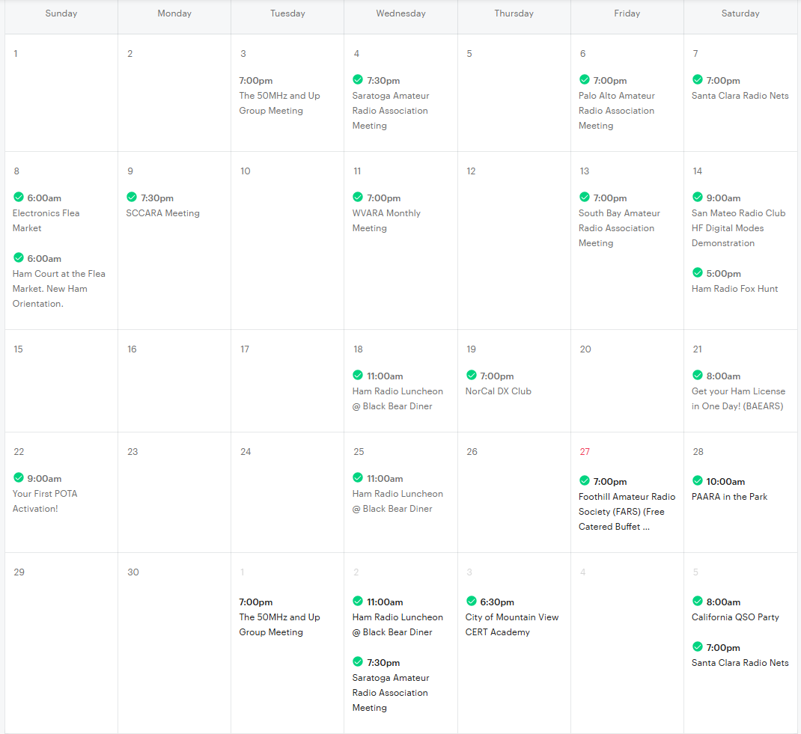

I am hoping that providing more opportunities for new hams to engage with us in their new hobby, we will inspire them to continue their journey.

This is phase one of the MeetUp Project. In phase two, I convince the clubs to take over posting their own events, and help them in hosting more hands on events that will appeal to folks who want to do more with Ham Radio. I am hosting such events myself to prove it can be done. I hope others are inspired to do likewise. I also hope to do joint events with other MeetUp groups to introduce them to Ham Radio, such as joint Summits on the Air activations with the Bay Area Hiking and Anything Fun group. I figure hikers might like the SOTA experience, and there are 7000 members (potential hams!) in that group…..

I also prepared a PowerPoint presentation that covers many of the varied activities in ham radio new hams may not know about. I know I keep getting surprised! It was only 12 years after I got my license that I learned about the 9am Talk Net. I want new hams to have all this at their fingertips, and not to have to dig for it.

# How do we build community?

The MeetUp Project is an ambitious project to revitalize our Ham Community. There are problems, however. As you probably are aware, a small percentage of hams carry a disproportionate amount of the workload. Club Officers are overworked, and volunteers are hard to find. New Hams may not bother connecting to a club, or an appropriate club, to help them along.

This brings us to the second phase of my outreach: Groups.IO. If you are not aware of Groups.IO, it is the same collaboration solution that County ARES/RACES uses. The site basically uses Email lists to send messages to a group of people, and members are able to communicate with the whole list. The advantage of Groups.IO is that contacts are able to add or remove themselves at will, so people do not receive spam on topics they no longer care about.

Members must join the “Announce” group to participate, and should only get 1 or 2 messages a month from said group. The Subgroups are another matter..

I have created a subgroup for every club in the Bay Area, and can create more if needed. This will help new hams easily find and contact any and all clubs in a single location.

More importantly, I have set up a group called “Ham Angels” for all of us who are willing to help out other clubs or organizations from time to time. This is where clubs can look for speakers, or volunteers to help at events. People who sign up don’t have any obligation to answer, just to consider requests that come along. I think we all benefit by working together, and this is the channel to use to do that.

There is also a channel especially for the Electronics Flea Market. Individual clubs may have trouble finding enough volunteers and may need outside help. In addition to the clubs, I intend to ask for volunteers to set up stations and operate at the Flea Market.

There is a channel for folks who need help coordinating a MeetUp event. I would like to see each club host periodic events especially to welcome new hams. Perhaps clubs can cooperate to sponsor such events?

# What can YOU do?

This is where I need your help. I cannot succeed in this mission alone. I need you to join me and contribute to this vision. I am not asking much:

1: Join MeetUp.com. I am not requiring you to host events. All I ask is that you join, check the calendar, and sign up for events you attend. If we want to attract new Hams, they need to see there are other people involved. Even though a club meeting may have 20 people show up, if the MeetUp only shows me and one or two other people signed up, prospective attendees are going to blow it off. Signing up shows them people care about what the club does.

2: Subscribe to Groups.IO.   
 If nothing else, join the group for your club(s). If you are willing to take part in promoting Ham Radio, join the relevant subgroups. If you have ideas, lets share them. I particularly welcome ideas for how clubs can cooperate on building and maintaining shared resources (CHIRP Files, lists of Nets, list of Clubs and contacts, Radio Cheat Sheets, Programming guides, etc) that will benefit all of us, and eliminate redundant work.

# What has SPECS done?

All that I have done, working with the other clubs, producing PowerPoint presentations to promote Ham Radio, the events on MeetUp.com are possible because the SPECS board has supported my efforts. In this, SPECS is responsible for doing more across the South Bay to promote Ham Radio than any other club. This year, I will be hosting a forum at Pacificon as an example of ways other clubs can follow our example.

At present, you can find links to everything I am working on at this stub website.

[qsl.net/k9stv/](https://www.qsl.net/k9stv/)

*The fileshare on this site is simply a copy of everything I have collected that you might benefit from, though I would like to see it eventually be a resource all the clubs contribute to. Intended to support CERT groups by providing a single internet file source to synchronize with to keep all your EmComm resources up to date.*