Wait a hamming minute: HamClock and Windows?
- By James Lathan
- March 10, 2023

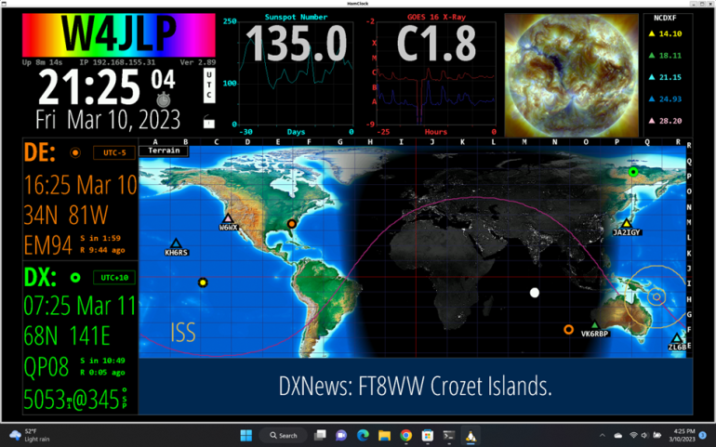Windows 10/11, WSL 2.0, Ubuntu 20.04.5 LTS
Want a program to display tons of Amateur Radio-related information? Many believe the only way to have a Geochron-like display is to install Linux on a dedicated system such as a Raspberry PI or a compatible PC or Laptop. Well, you can do that and have a reliable system displaying this beautiful screen on a large TV monitor. But, what if you don’t have a Raspberry Pi or spare PC? You can run the application in a little-known Linux sub-system environment in Windows.
With a few simple commands, you can run Linux programs like Hamclock in Ubuntu WSL. To learn more about Windows Linux Subsystem (WSL), click https://learn.microsoft.com/en-us/windows/wsl/about.
Let’s get started. First, you will want to make sure your system is up-to-date with all system updates. Next, let’s install Ubuntu 20.04.5 LTS from the Microsoft Store, follow the link https://www.microsoft.com/store/productId/9MTTCL66CPXJ to install. Follow the prompts to create your user and password.
At the command prompt do the following:
- sudo apt-get update
- sudo apt-get upgrade
- sudo apt install curl make g++ xorg-dev libx11-dev zip
- cd
- rm -fr ESPHamClock
- curl -O https://www.clearskyinstitute.com/ham/HamClock/ESPHamClock.zip
- unzip ESPHamClock.zip
- cd ESPHamClock
- make -j 4 hamclock-web-1600x960
- make -j 4 hamclock-web-800x480

- sudo make install

Windows PC:
Open a CMD window and run the below command:
wsl sudo hamclock &
Hamclock can now be accessed from the web browser on http://127.0.0.1:8081/live.html or
from the rest of your network on http://[IP/HostName of Windows 10 machine]:8081/live.html

Auto Start hamclock
Create scheduled task on windows to run the following command from cmd.exe every time the computer starts:
wsl sudo hamclock &
Hamclock details and information is at https://www.clearskyinstitute.com/ham/HamClock/
Enjoy and 7 3
Jim, W4JLP

