Winlink on FT710, VARA HF
Winlink on FT710, VARA HF
After struggling for some time and reaching out for help, I finally got Vara HF Winlink up and running with Windows 11 on my FT710. Here are screen shots of the VARA and Winlink settings. Computer is connected to the 710 via USB cable.

I can say that I am up and running with the settings as shown.

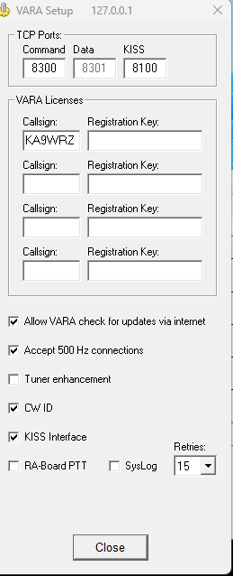

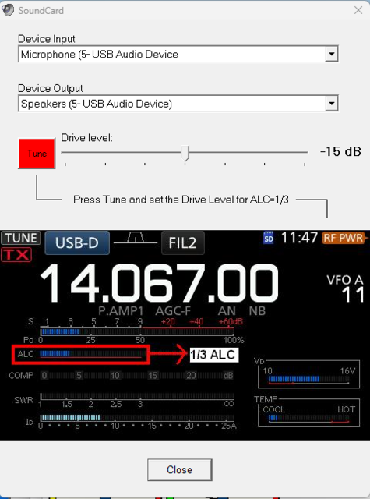

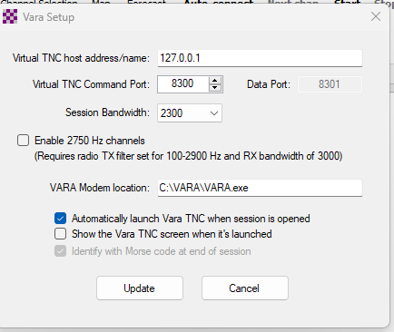

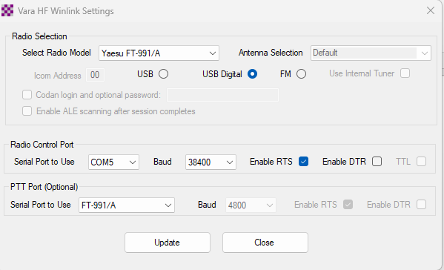

Winlink on FT710, VARA HF
turned the power down to about 15w, running Preset 2 with RTS (may have already been set there without me having to adjust, but don't recall so that's where it is now). Also, running DATA-U.
Vara seems much faster (to me) than ARDOP.

