WSJT-X Split Operation and Why Use It

BY [K0PIR](https://k0pir.us/author/rich/) · PUBLISHED APRIL 22, 2018 · UPDATED APRIL 24, 2018

I’m going to make the case for using Split Operation in the WSJT-X program. Recently I took a poll on the WSJT-X Facebook page and got some interesting results. Almost twice as many Hams use “Fake It” than “Rig” for Split Operation. There are still many that use “None”.

Modern HF transceivers are capable of using “Rig” for Split Operation, however most Hams end up using “Fake It” because of either radio problems, timing issues or just plain simplicity. I have been using “Fake it” for a long time and just recently revisited using “Rig”. Both work very well. *Note: If you are using the Icom 7300 or 7610 and Ham Radio Deluxe for the Rig in WSJT-X, you will have to use “Fake It” for Split Operation.*

](https://k0pir.us/wp-content/uploads/2018/04/wsjtxsplit-1.jpg)

Split Operation Explained

The Split Operation that I am talking about here is the setting on the Radio tab in WSJT-X. For split we have three choices, Fake It, Rig or None.

*There is another split method that we can use when trying to make contacts and that involves using the option in WSJT-X to “Hold TX Frequency”. More on that later.*

What is Split Operation and why is it useful?

*Significant advantages result from using Split mode (separate VFOs for Rx and Tx) if your radio supports it. If it does not, WSJT-X can emulate such behavior. Either method will result in a cleaner transmitted signal, by keeping the Tx audio always in the range 1500 to 2000 Hz so that audio harmonics cannot pass through the Tx sideband filter. Select Rig to use the radio’s Split mode, or Fake It to have WSJT-X adjust the VFO frequency as needed, when T/R switching occurs. Choose None if you do not wish to use split operation. – WSJT-X Manual*

The Case For Using Split Operation

I think it’s important to use Split Operation in the WSJT-X settings and here’s why.

Let me show you what I found out from operating PSK31.

If you ever operated PSK31 you may have noticed when moving too far off center that the power output level will go down. To compensate for this, some software (WinWarbler) offers the option to optimize or set the transceiver frequency to achieve optimal offset.  It will shift your frequency for you.

This is basically what the Split Operation will do in WSJT-X, but WSJT-X does it on the fly. It uses the optimal offset and puts your TX audio in the range of 1500 to 2000 Hz automatically for you and leaves the RX frequency alone. Nice!

With WSJT-X and using “None” you may not see the loss of power if transmitting out of 1500 to 2000 Hz like when in PSK31 mode, but there is the risk of creating IM within the TX passband.

If I look at it in terms of my experience with PSK31, I’m going to naturally want to use Split Operation in WSJT-X. I’ll have a cleaner signal and I think it increases my chances of making the contact. Also, a cleaner signal makes everyone around me happy.

Holding the TX Frequency

The other split reference we here about is using the option, “Hold TX Frequency”.

[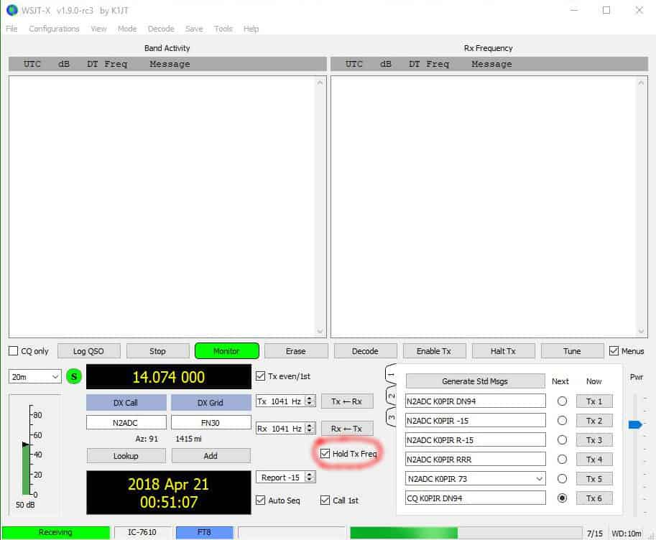](https://k0pir.us/wp-content/uploads/2018/04/wsjtxholdtx-1.jpg)

I always use “Hold TX Frequency” when calling CQ, because I don’t want to lose my TX frequency.

Some experienced users exclaim, “Don’t call me on my transmit frequency”. It’s not a hard and fast rule, but makes sense, especially in a DX pileup situation.

If you select the option “Hold TX Frequency” in WSJT-X to hold the TX frequency and then place your red TX indicator in a clear spot on the waterfall (wide graph) it may help you get the DX station that everyone is calling.

[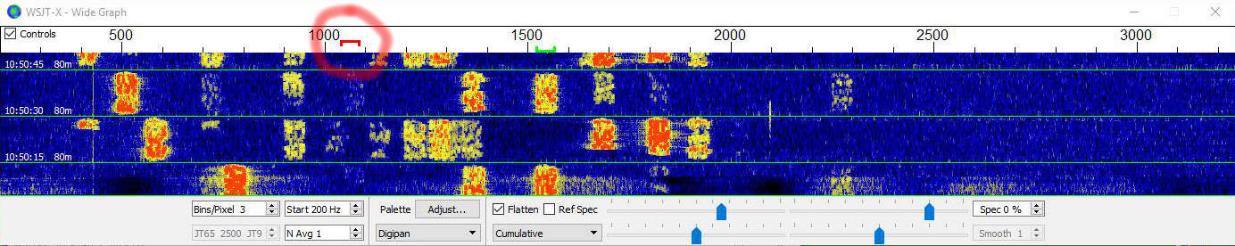](https://k0pir.us/wp-content/uploads/2018/04/wsjtxwaterfall-2.jpg)

The reasoning behind this: Others will be calling the DX station on the DX stations TX frequency (simplex). So instead of getting caught up in the pileup, try this split method.

I know many Hams use this method, because when I call CQ others respond off of my TX frequency.

I have to admit though, to this date, I’ve been disappointed. I don’t know why, but I have better success using simplex and calling a station on it’s TX frequency. I still think split is worth trying when calling a DX station and I’ll continue to try it for North American stations too. Just my 2 cents on that subject.

Conclusion

I encourage everyone to try using Split Operation, either “Rig” or “Fake It”. It may take a little getting used too. If it doesn’t work for you then use “None”. It’s not the worst thing, especially if you don’t use excessive power. You could also try to stay in the 1500 to 2000 Hz range too.

I hope you find this information useful. Thank you for coming by and I hope to hear YOU, on the air!

So how do you use the “Hold TX Frequency” option?

If you have any questions or comments, please post them below. Your experience will help someone else. I’ll do my best to answer questions and reply.

73,

Rich, K0PIR

Sources:

[FT8 Hinson Tips for HF DXers](https://k0pir.us/wp-content/uploads/2018/04/FT8_Hinson_tips_for_HF_DXers.pdf)

[WSJT-X](http://physics.princeton.edu/pulsar/k1jt/wsjtx-doc/wsjtx-main-1.7.1-devel.html#RADIO)

[Frode, LA6VQ in QRZ.com Forum](http://forums.qrz.com/index.php?threads/a-new-spin-on-jt-alert-hrd-logbook-and-wsjt-x.606724/)

*UPDATE: Very informative comments below. I just want to clarify using Split Operation as mentioned first. If using Rig or Fake It, it just shifts your TX frequency to put your TX in the sweet spot of 1500 to 2000 Hz. When using it, if your TX and RX indicators are lined up on the same frequency in the wide graph, you will still not be running the traditional split mode, it is simplex, ie. calling on the TX frequency of the other station. Thanks so much for the very informative comments.*